Sprint1 - Jira - stripe-provider-service git setup - Working with Spring Profile
(WEEK3-DAY1)

✅ WEEK 3 – SPRINT 1 (Feb 16 – Feb 27)
🔹 What is a Sprint?
- 2-week working cycle
- Team decides how many features they can complete
- Daily work → Move tasks across board → Deliver fully working features
- Day 1 = Sprint Planning Meeting

🛠 1️⃣ JIRA SETUP (Mandatory First Step)
Create Project
- Create free Jira account (Gmail login)
- Use Scrum template
- Give proper project name
Create Sprint
- Go to Backlog
- Create new sprint → Feb26 Sprint1
- Set start & end dates
- Define sprint goal:
Setup Stripe Provider Microservice and integrate Create Order API
Add User Stories (Move to Sprint)
Add these as separate User Stories:
- Setup stripe-provider-service (with Maven + Profiles)
- Explore REST API & REST standards in Spring Boot
- Integrate Stripe CreateOrder API
- Implement Basic Auth during Create Order
- Error Handling in stripe-provider-service
- Incoming Notification / Webhook Handling
- Deploy stripe-provider in AWS & testing
- Add project in resume (Week 4 Day 5)
Start Sprint

🔹 Configure Board Columns
Default:
- TODO
- IN PROGRESS
- DONE
Add:
- QA
- WAITING FOR BUGFIX
Status Flow:
TODO → IN PROGRESS → QA → DONE
↓
WAITING FOR BUGFIX

🏗 2️⃣ Project Architecture Overview
Payment Integration Overview:
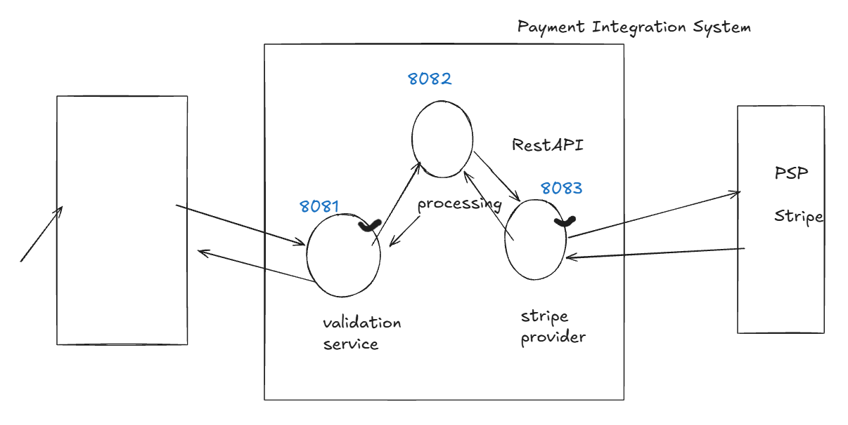

Payment Integration System (Microservices)
- Validation Service
- Payment Processing Service
- Stripe Provider Service ← (Focus this week)
Communication: REST APIs
Tech: Java + Spring Boot + Maven

🌿 3️⃣ Bitbucket Setup (Professional Workflow)
Create Repository
- Repo name = stripe-provider-service
- Create:
  - main branch
  - integration branch
Create Feature Branch
initial-service-setup
🚫 Never code directly in:
- main
- integration
Always:
Feature branch → Pull Request → Merge to integration

🖥 4️⃣ Local Setup Process (Very Important)
Now we want to clone the project, in last session we did this by going to sourcetree and then went to remote and cloned from there
Now, we will try second approach o clone the project. For this, go to bitbucket and go to feature branch in branches section and then -
- Checkout feature branch from Bitbucket in SourceTree
- Clone to organized local folder
Naming syntax –
Drive/mainprojectname/repofolder/microservice1name/featureofmicroservice
C:/PaymentIntegrationProject/repo/stripe-provider-service/stripe-provider-initial-setup

- Copy zip project code into clone location
- Import Maven project (not original zip folder)
- Run application
- Confirm:
  - Runs on correct port (8083)
  - Tomcat starts successfully
- Commit & push initial draft
- Raise PR → Merge to integration

📘 Stripe Provider Microservice – Setup Notes

clean, structured notes — combining:
- Your mentor’s setup process
- The AI summary
- Your own independent project setup
These will be proper microservice setup notes for revision.
1️⃣ Purpose of This Project
- Build a Java Spring Boot microservice
- It will run as an independent service
- Exposes REST APIs
- Runs on a specific port
- Packaged as a JAR
- Built using Maven

2️⃣ Tech Stack
- Java 17 (mentor) / Java 21 (mine)
- Spring Boot 3.x
- Maven
- Embedded Tomcat (comes with Spring Web)

3️⃣ Project Creation (start.spring.io)
This is the “Getting Started” code.
Initial project contains:
- Only main Spring Boot application file
- No business logic
- pom.xml
- application.properties

4️⃣ Group ID & Package Structure
Mentor:
com.hulkhiretech
This represents:
- Company domain
- Base package for entire project
My version:
com.bharti
All Java files must be inside this base package.

5️⃣ Important Dependencies
✅ spring-boot-starter-web
- For REST APIs
- Includes embedded Tomcat
✅ spring-boot-starter-test
- JUnit (unit testing)
- Mockito (mocking)
✅ DevTools
- Auto restart on save (development only)
✅ Lombok
- Reduces boilerplate (getters, setters, constructors)
✅ ModelMapper
- Object-to-object mapping (DTO ↔ Entity)

6️⃣ Application Configuration
application.properties contains:
- Server port
- Application name
- Profile configurations
Mentor project includes:
- Multiple profiles (dev, qa, prod)
Profiles allow:
- Different configurations per environment

7️⃣ Git & Bitbucket Workflow
Repository Setup
- Create repo in Bitbucket:
- stripe-provider-service
- Create branches:
  - main
  - integration

Important Rules
- ❌ Never code directly in main
- ❌ Never code directly in integration
- ✅ Always create feature branch
- ✅ Merge via Pull Request only
Example:
feature/payment-init
bugfix/stripe-timeout

8️⃣ Working with Clone Location
Very Important:
- Always code inside the cloned repository
- Never code in original ZIP folder
- Maven project must be inside clone directory
- Git only tracks code inside cloned repo

9️⃣ Jira Tracking
For every task:
- Create Jira ticket
- Mention high-level steps
- Update status regularly
- Highlight practical work done
Jira tracks:
- Repo creation
- Branch creation
- Project import
- Initial setup

🔟 Build Configuration
Final jar name:
<build>
<finalName>stripe-provider-service</finalName>
</build>
Command to build:
mvn clean package
Output:
stripe-provider-service.jar

1️⃣1️⃣ Microservice Best Practices (Important)
- Add dependencies only when required
- Keep project minimal initially
- Profiles separate environment configs
- Git flow discipline is mandatory
- Dependency setup is usually one-time activity

1️⃣2️⃣ Current Status (Your Version)
You are:
- Not using mentor ZIP
- Creating project from scratch
- Using your own package name
- Using Java 21
- Keeping dependency list same for now
This is correct approach.

Working with profile & environments
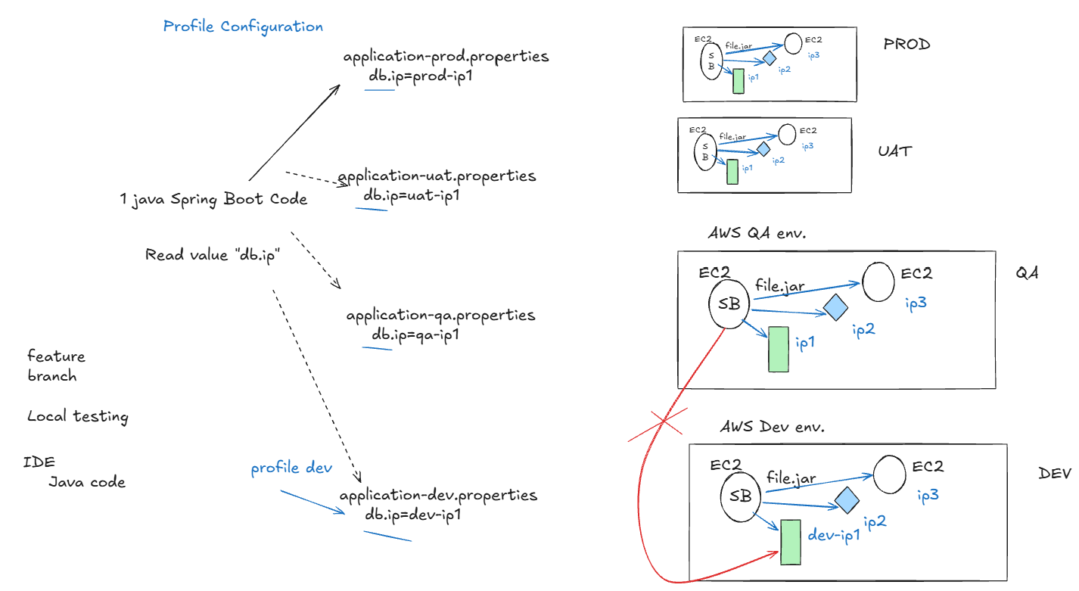

Profile
• A profile is a name given to a set of environment-specific configurations for your Spring Boot app
• Each environment (Dev, QA, UAT, Prod) has different machines like DB, Redis, etc., each with their own IPs
• When a microservice runs in an environment, it must connect only to services of that environment, never another environment’s services
• Profiles let the app handle this automatically using property files: application-<profile>.properties (e.g., application-dev.properties)
• Property files store environment-specific settings like DB IPs, Redis, other MS URLs
• At runtime, you choose a profile → app reads correct property file → connects to correct environment
• Two ways to implement: Spring Profile OR Spring Profile + Maven Profile
• Steps: create env-specific property files → choose profile while running → app picks correct config automatically
We will do practical with profile concept, but before that
• Test locally: http://localhost:8083/add?val1=10&val2=50
• Check logging.path in pom.xml before running to match your machine.
• Commit + push to feature branch.
• Merge to integration via pull request.

